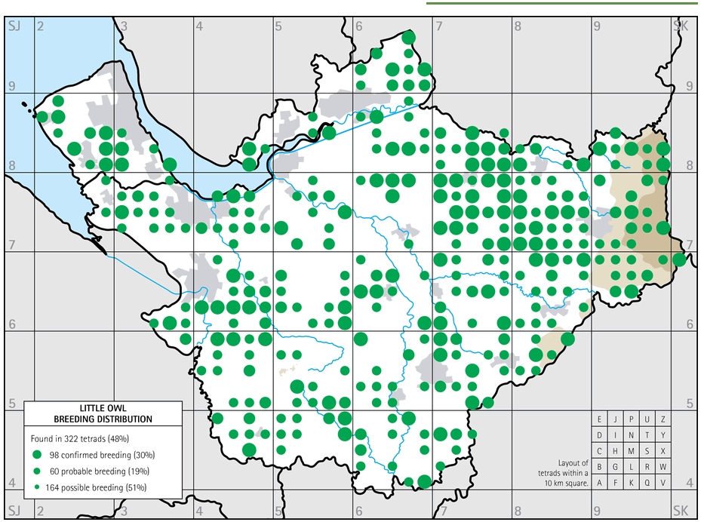
Little Owl Breeding Distribution
Selecting your survey points.
Given the survey is a pilot this year with a view to scaling up next year. It would be preferable if you can if possible, select your survey points in the areas where suitable habitat occurs in tetrads with confirmed breeding during the last CAWOS breeding bird atlas.
However, If this isn’t possible, please undertake a survey within suitable habitat in your preferred location. I am interested in the function of the survey methods and surveyor feedback therefore, even if you can’t visit the preferred tetrads that isn’t a problem.

